WEB DEVELOPMENT COURSES (WBC) PROJECT

Software Requirements Specification

|  |  |  |  |
| --- | --- | --- | --- |
|  | Prepared By | Reviewed By | Approved By |
| Name | Nikitha Gowda | Chandrasekar, Venkataraman |  |
| Role | Interns | Batch Trainer |  |

**Table of Contents**

Table of Contents…………………………………………………………..….......II

1. Introduction…………………………………………………………………..…1

1.1 Intended Audience……………………………………………….......1

1.2 Project Scope…………………………...……………………………1

2. Overall Description…………………………………………….……………….1

2.1 Operating Environment……………………...……………………....1

3. Requirements……………………………………………………………...…….1

3.1Login………………………………………………………………….2

3.1.1Description………………………………………………....2

3.1.2 Functional Requirements……..…………………………...2

3.1Login………………………………………………………………….2

3.1.1Description………………………………………………....2

3.1.2 Functional Requirements……..…………………………...2

**1. Introduction**

Practo Drive is an online website. We are taking and testing five functionalities of that website (i.e.)

1). For Bangalore city, identify first 20 Hospitals that has rating more than 3.5; Display the hospital names.

2). Go to Book Diagnostic Tests, pick all the top cities name & store in a List; Display the same.

3). Navigate Back to Homepage and under View all specialties, print all specialties along with price.

4). Under For hospitals, click on practo drive. Then provide invalid details, capture the warning message.

5). Check whether Instagram is available under social menu.

**1.1 Intended Audience**

Business Unit (BU) SME

Academy coach

Technical Trainer

**1.2 Project Scope**

This document defines at a functional level the business activities that are encompassed by the system and the rules that apply to them. It also encompasses some of the key high- and low-level technical requirements of the system.

It draws heavily on both proposed Framework and Business Rules and the Technical Architecture documents. The scope of the detailed analysis project phase specifies that this document will include.

· Classification of requirements according to their functional areas.

· A description of each process in the system, including their inputs, outputs, and data transformation rules.

**2. Overall Description**

**2.1 Operating Environment**

Windows operating system

Web application

**3. Requirements**

This part of the requirements document serves to present the "Interest amount for current year" of the application and, we need to extract all the levels in Validation of transactions & do calculations, Extract table values & store in excel, Filling data in screen & multiple UI validations.

**3.1.1 Functional Requirements**

**3.1.1.1 Req0001**

**Req0001a-**The user navigates to location search.

**Req0001b**- The user enters the location as “Bangalore”.

**Req0001c-**The user enters “Hospital” in the search box.

**Req0001d-** The user enters captures the first 20 hospitals having rating more than 3.5.

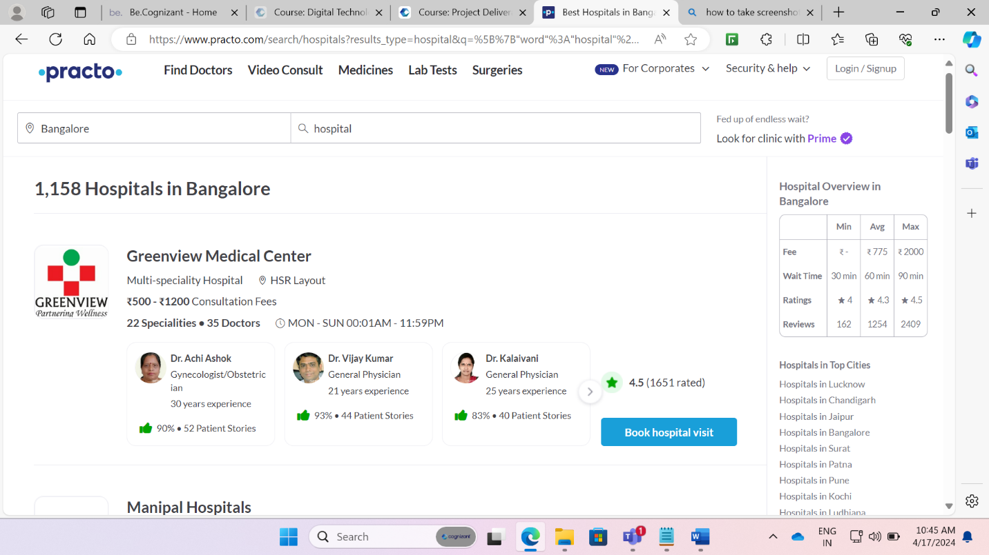

**3.1.1.2 Req0002**

**Req0002a**- The user navigates to “Book Diagnostic Tests”.

**Req0002b-** The user fills the relevant details.

**Req0002c-** The user extracts the data from top cities table to excel.

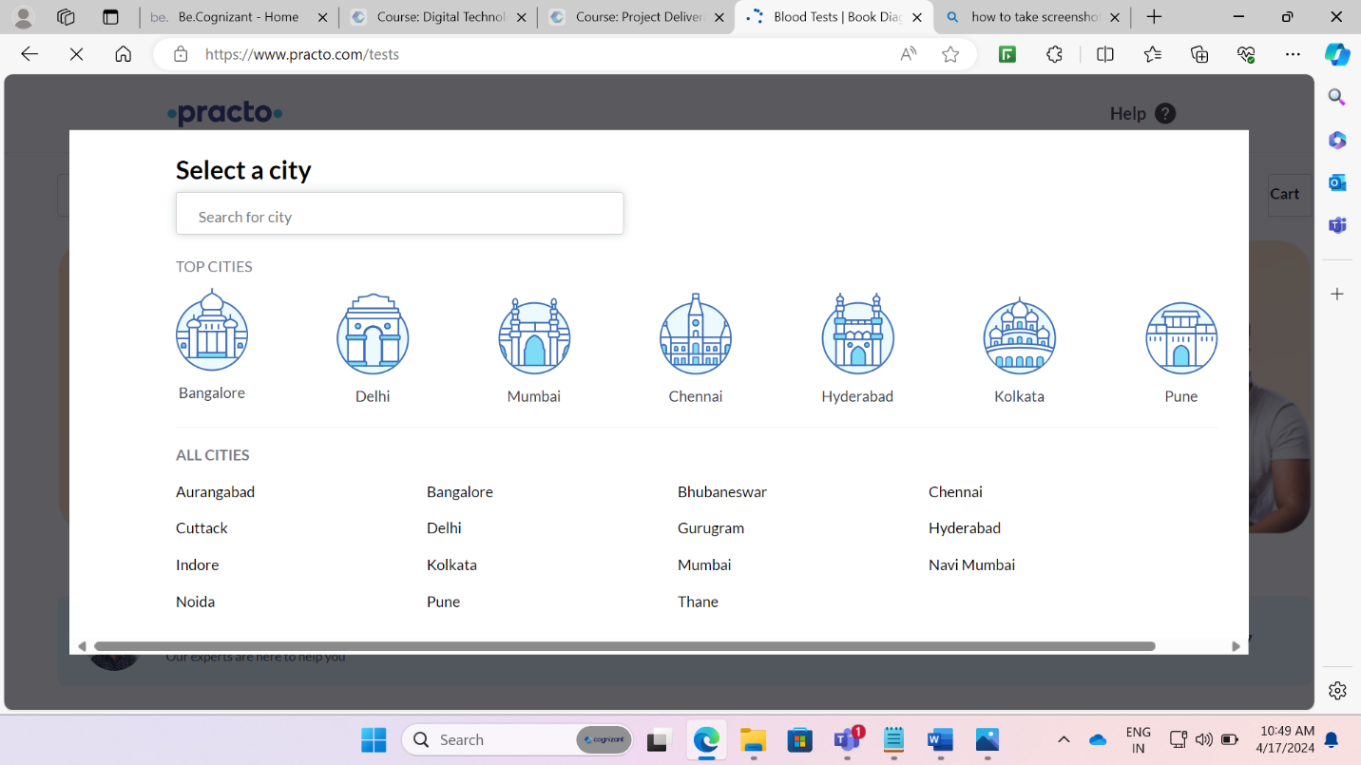

**3.1.2.3 Req0003**

**Req0003a**- The user navigates to Home Page.

**Req0003b-** The user navigates to view all specialties.

**Req0003c-** The user stores the all the specialties along with the price in a excel file.

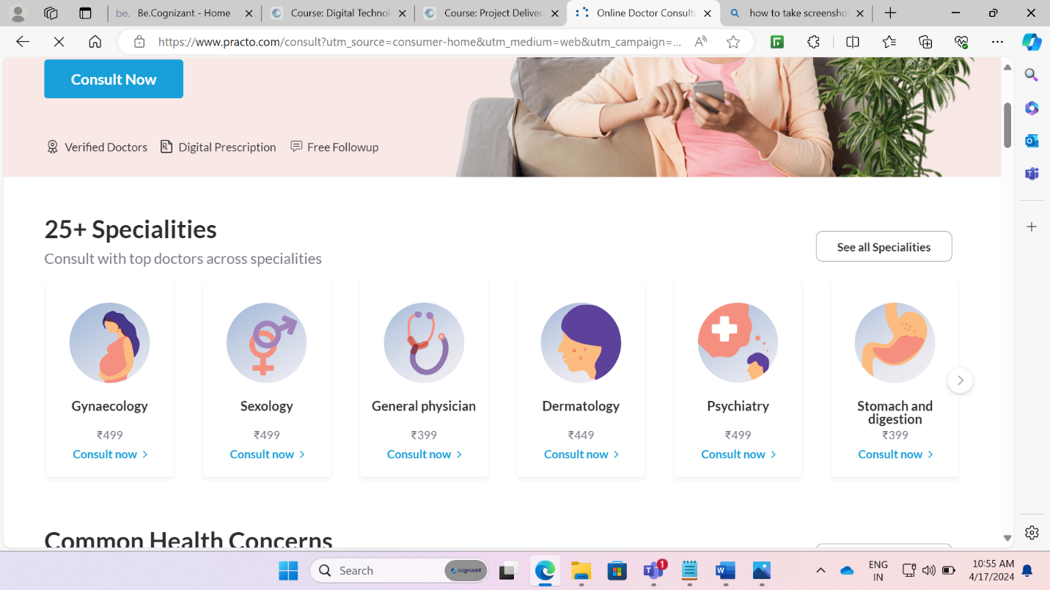

**3.1.2.4 Req0004**

**Req0004a**- The user navigates to Home page.

**Req0004b-** The user navigates to for Hospital.

**Req0004c-** The user clicks on the practo drive.

**Req0004d-** The user enters invalid details.

**Req0004e-** The user captures the warning message.

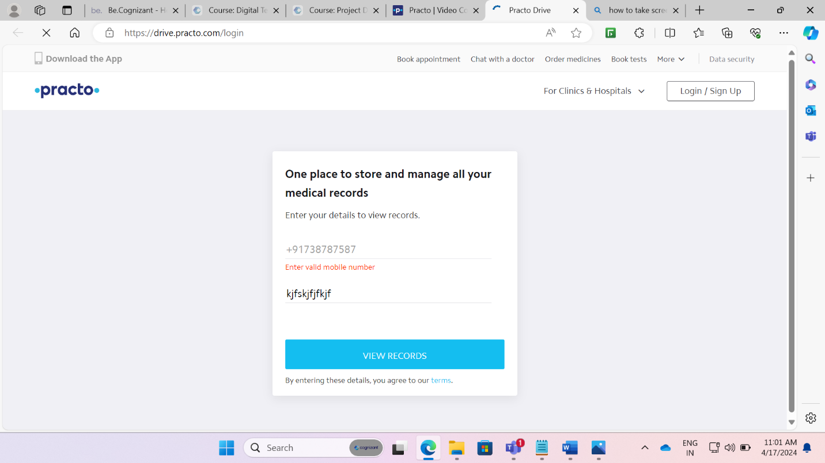

**3.1.2.4 Req0005**

**Req0005a**- The user navigates to social menu.

**Req0005b-**The user validates whether Instagram is available under the social menu

